* **CORRECT RESPONSE OBJECT STRUCTURE**

Proper ResponseEntity object returned that is compatible with HAL standards.

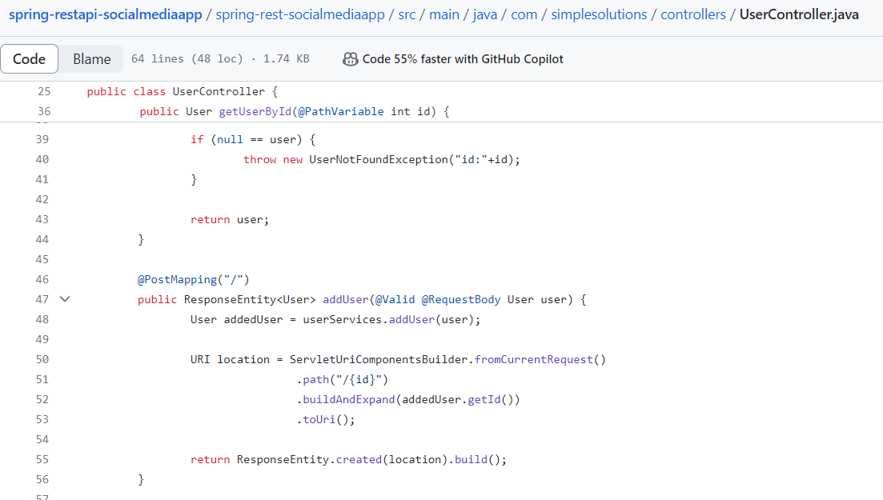

* **INPUT VALIDATION**

Proper input data validation using @Valid annotation. Also, applying desired validations on the entity class fields.



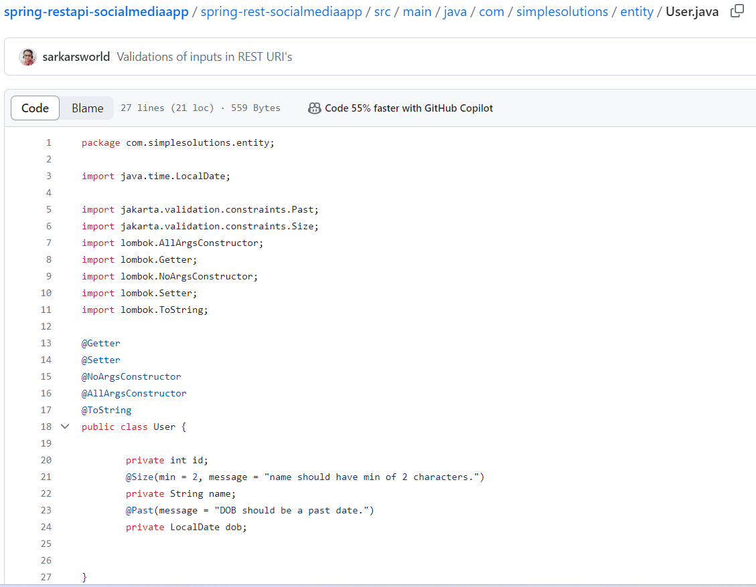

* **CUSTOM EXCEPTION HANDLING**

Proper exception response object returning is must. It must contain necessary information for the receiver to understand the exception and the cause.

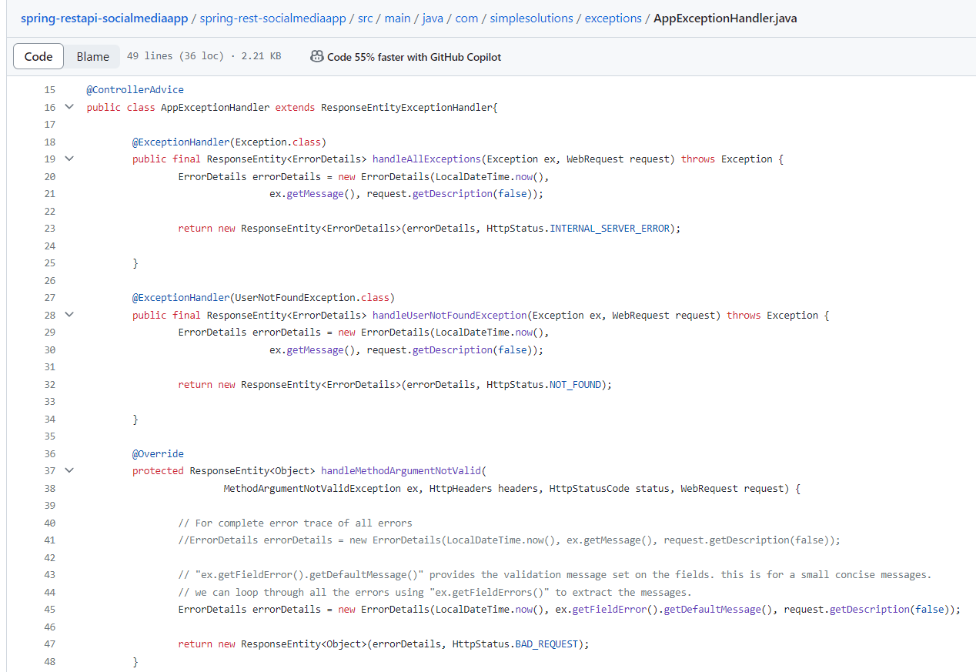

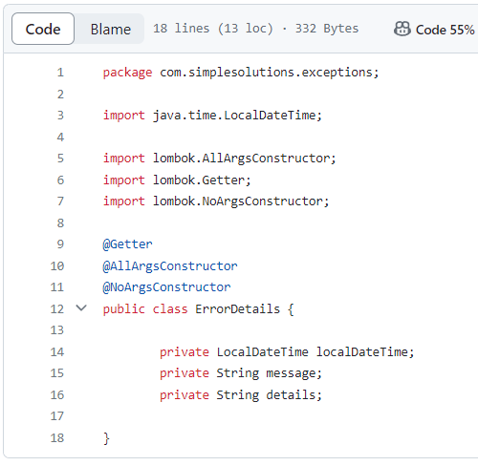

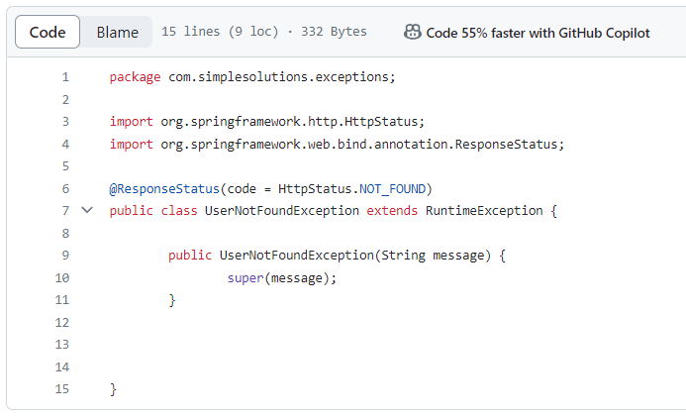

* **ADVANCED REST API FEATURES**

1. DOCUMENTATION

2. CONTENT NEGOTATION.

3. INTERNATIONALIZATION

4. VERSIONING

5. HATEOAS

6. STATIC FILTERING

7. DYNAMIC FILTERING

8. MONITORING

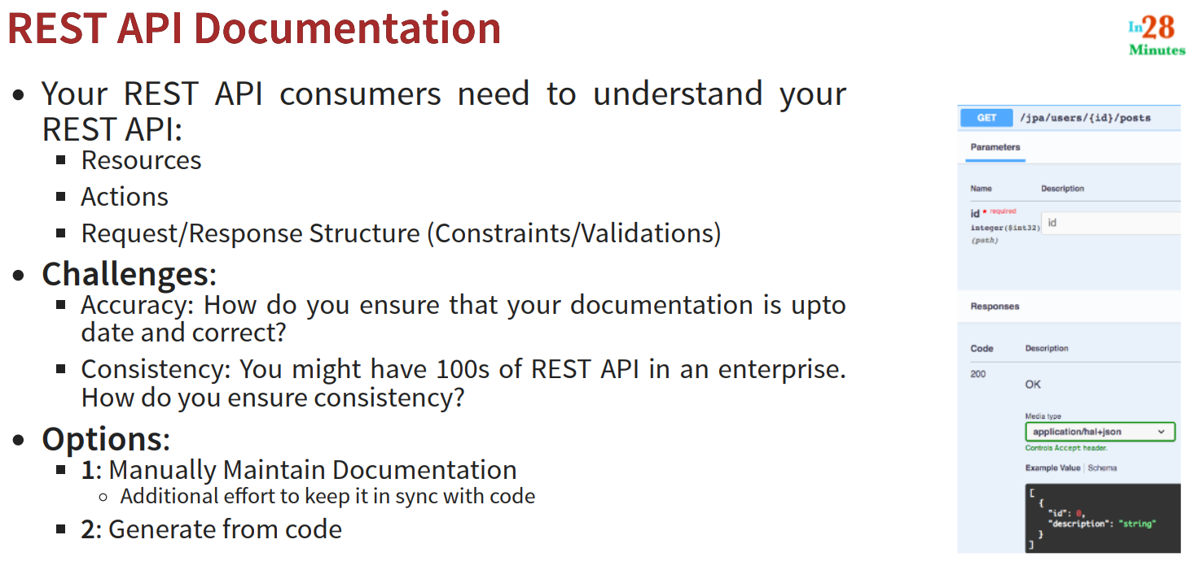

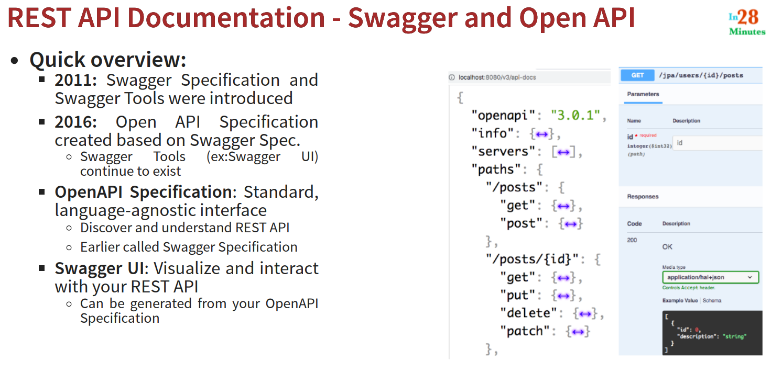

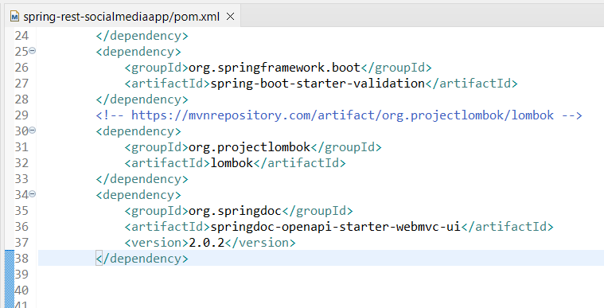

**Just adding openapi dependency will help us get the swagger documentations.**

